FTP packet capture lab

Introduction:
· Control channel (điều khiển) luôn là TCP port 21 — client gửi lệnh (USER, PASS, PORT, PASV, RETR, STOR...), server trả lời.
· Data channel (dữ liệu) là kênh riêng dùng để truyền file/listing. Cách thiết lập data channel khác nhau → tạo ra hai chế độ: Active (PORT) và Passive (PASV).

Active and Passive FTP:
Active FTP (PORT)
Quy trình:
Client mở kết nối TCP tới server:21 (control).
Khi client cần truyền/nhận dữ liệu, client mở một port listening cục bộ (ví dụ client chọn port 34567) và gửi lệnh PORT a,b,c,d,p1,p2 cho server qua control channel. a.b.c.d là IP client, port = p1*256 + p2.
Server kết nối ngược tới client trên a.b.c.d:port để thiết lập data connection.
Ai lắng nghe data? → Client lắng nghe, server kết nối tới client.
Vấn đề với NAT/Firewall: server không thể kết nối vào client nếu client ở sau NAT/firewall (chưa có port mở). Vì vậy Active FTP hay gặp lỗi khi client là máy sau NAT.
Passive FTP (PASV)
Quy trình:
Client mở kết nối TCP tới server:21 (control).
Khi cần data, client gửi PASV tới server.
Server trả 227 Entering Passive Mode (h1,h2,h3,h4,p1,p2). h1.h2.h3.h4 là IP server, port = p1*256 + p2.
Client mở kết nối tới server:port đó để truyền dữ liệu.
Ai lắng nghe data? → Server lắng nghe cả control và data passive port; client kết nối đến server.
Passive thuận tiện khi client ở sau NAT/firewall vì client khởi tạo cả hai kết nối (control + data) ra ngoài.

Tổng quan:
Control luôn trên port 21 (USER/PASS, PORT/PASV commands).
Active (PORT): client mở port và server kết nối ngược tới client để truyền dữ liệu.
Passive (PASV): server mở port động và client kết nối tới server để truyền dữ liệu.
Trước khi bắt data, luôn capture control (port 21) để biết server trả PASV hay client gửi PORT → từ đó xác định data port.

Now lets set up the FTP lab:
- FTP server: ip address 192.168.139.136
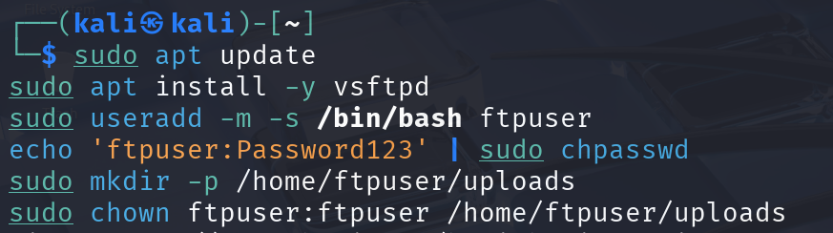
FIrst, install the vsftpd and create a user.
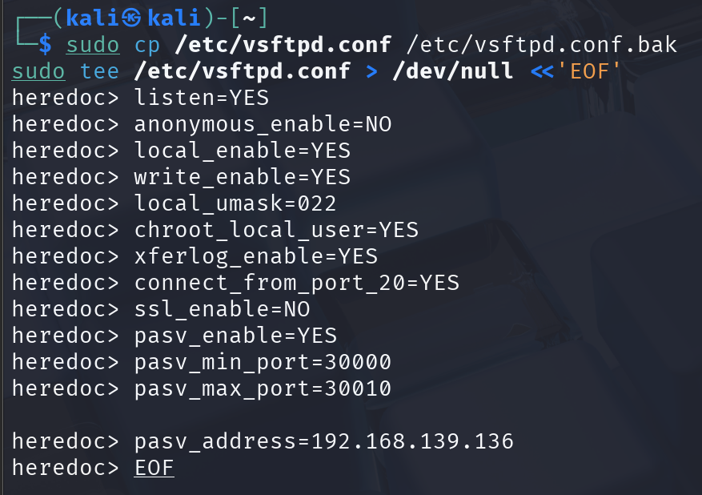
Then, setup the FTP server, create a BACKUP first because I have already made a wrong configurations before(hehe).
Explain part:
· listen=YES
Tells vsftpd to run in standalone mode and listen on the FTP port (21).
· anonymous_enable=NO
Disables anonymous FTP logins. Only local (real) user accounts can authenticate.
· local_enable=YES
Allows local system users (accounts in /etc/passwd) to log in.
· write_enable=YES
Enables write commands (e.g., STOR, DELE). Without this, clients can only download/read files.
· local_umask=022
Sets the permission mask applied to uploaded files by local users. 022 results in files created with permissions rw-r--r-- (owner write, others read).
· chroot_local_user=YES
Restricts (jails) local users to their home directories after login. This prevents users from navigating the rest of the filesystem.
· xferlog_enable=YES
Enables logging of file transfers to the transfer log (usually /var/log/xferlog), which helps auditing what was uploaded/downloaded.
· connect_from_port_20=YES
Tells vsftpd to use source port 20 for active-mode data connections where applicable (traditional FTP behaviour). This can be useful when clients or firewalls expect the server data connection to originate from port 20.
· ssl_enable=NO
Disables SSL/TLS for FTP (FTPS). This makes FTP traffic plaintext (USER/PASS and file contents).
· pasv_enable=YES
Enables passive mode support. Passive mode causes the server to open a data port and the client to connect to that server port. Passive mode is NAT/firewall-friendly for clients and is easier to capture in a lab when you control the passive port range.
· pasv_min_port=30000 and pasv_max_port=30010
Define a small, fixed range of passive data ports (30000–30010).
· pasv_address=192.168.139.136
The public IP address the server reports back to the client in the 227 Entering Passive Mode (...) response.
Create a place to for user to upload.
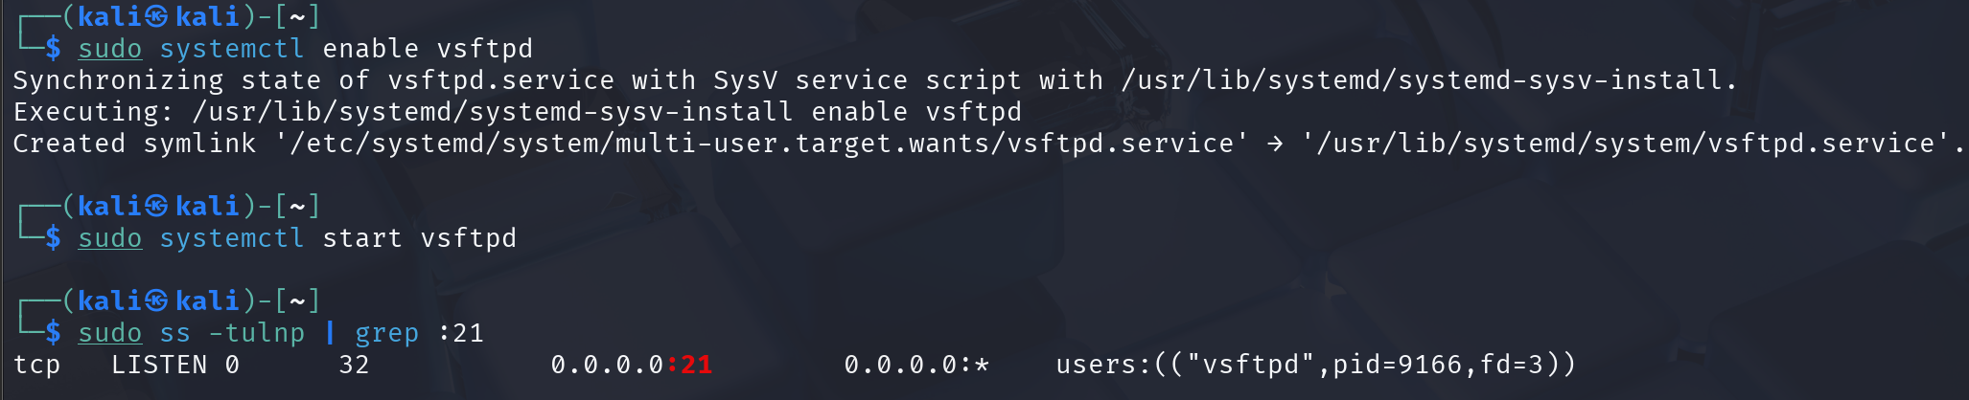
Final, enable and start the service, we can see that it is now running on port 21.

Okay so now we will have 2 scenarios, the first one is passive FTP and the second one is active FTP.
- Passive FTP capture:
+ Victim: 192.168.139.137
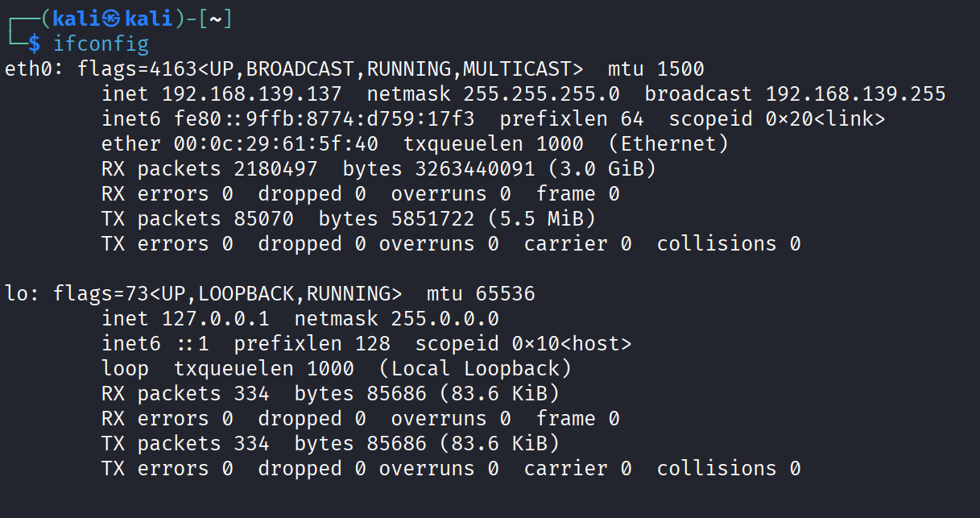
Now lets setup the victim first
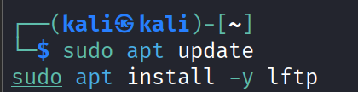
First, install lftp.
Then upload a file to the FTP server.

+ Attacker: ip address 192.168.139.135
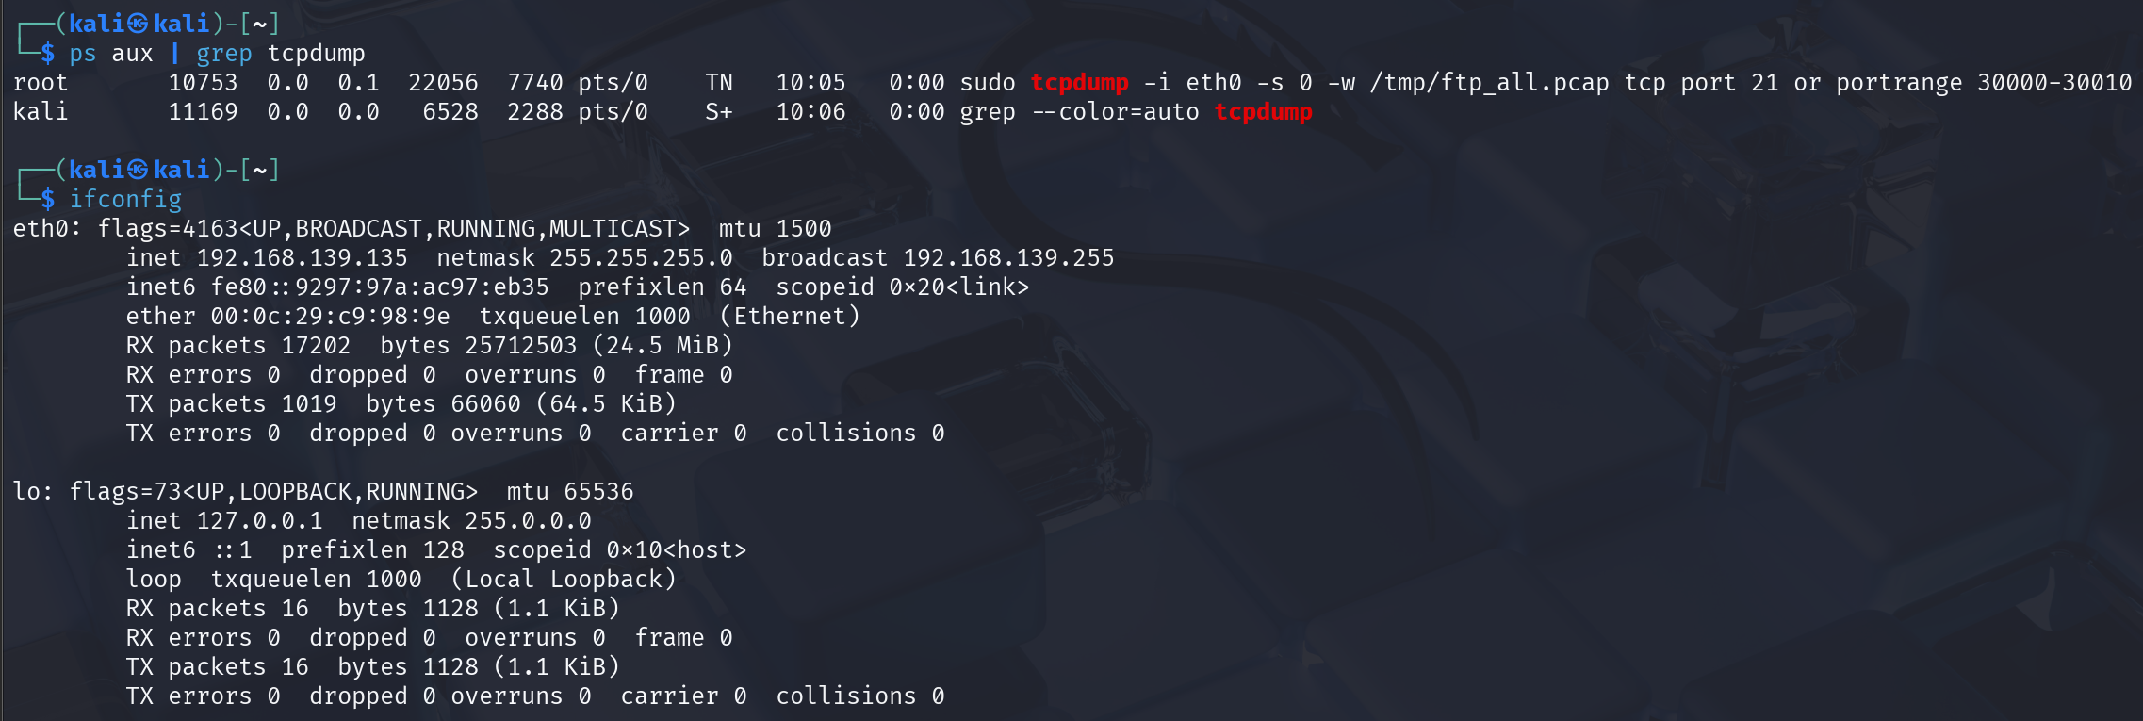
Turn on the tcpdump with fix port range ( assume that attacker now the port range of the FTP server uses )
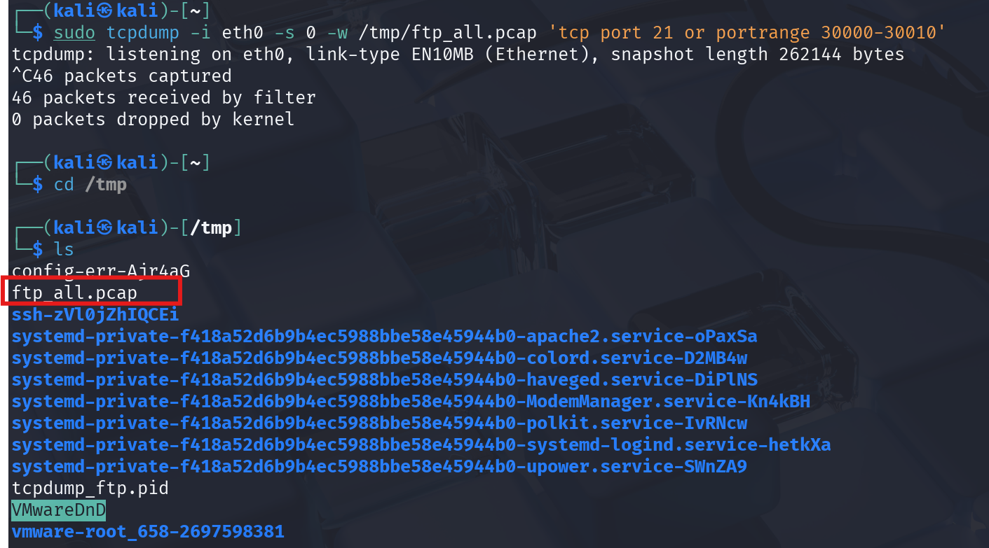
After the user has upload the file to the server, turn off the tcpdump and lets analyze the pcap file
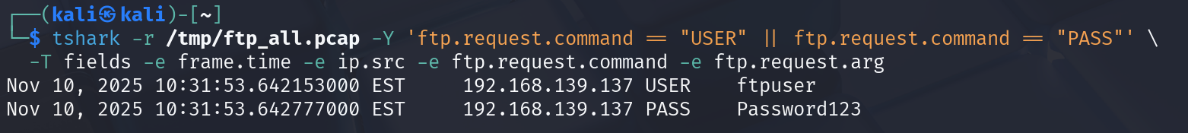
With tshark, we successfully now the username and password that the victim use to login to FTP server.
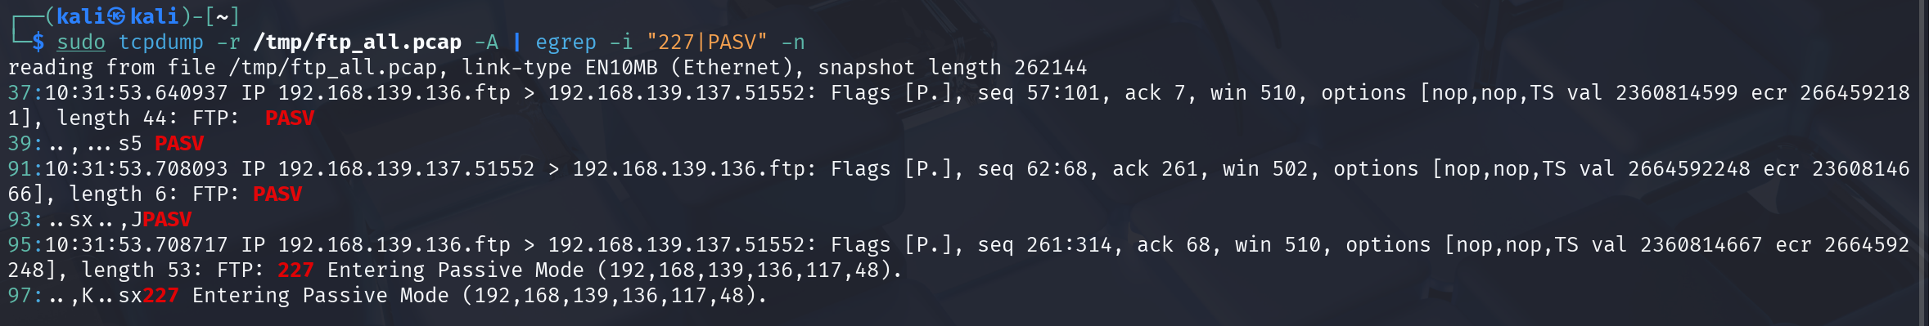
PASV response. With this we can calculate the port with the formula: port= 117*256 + 48 = 30000.
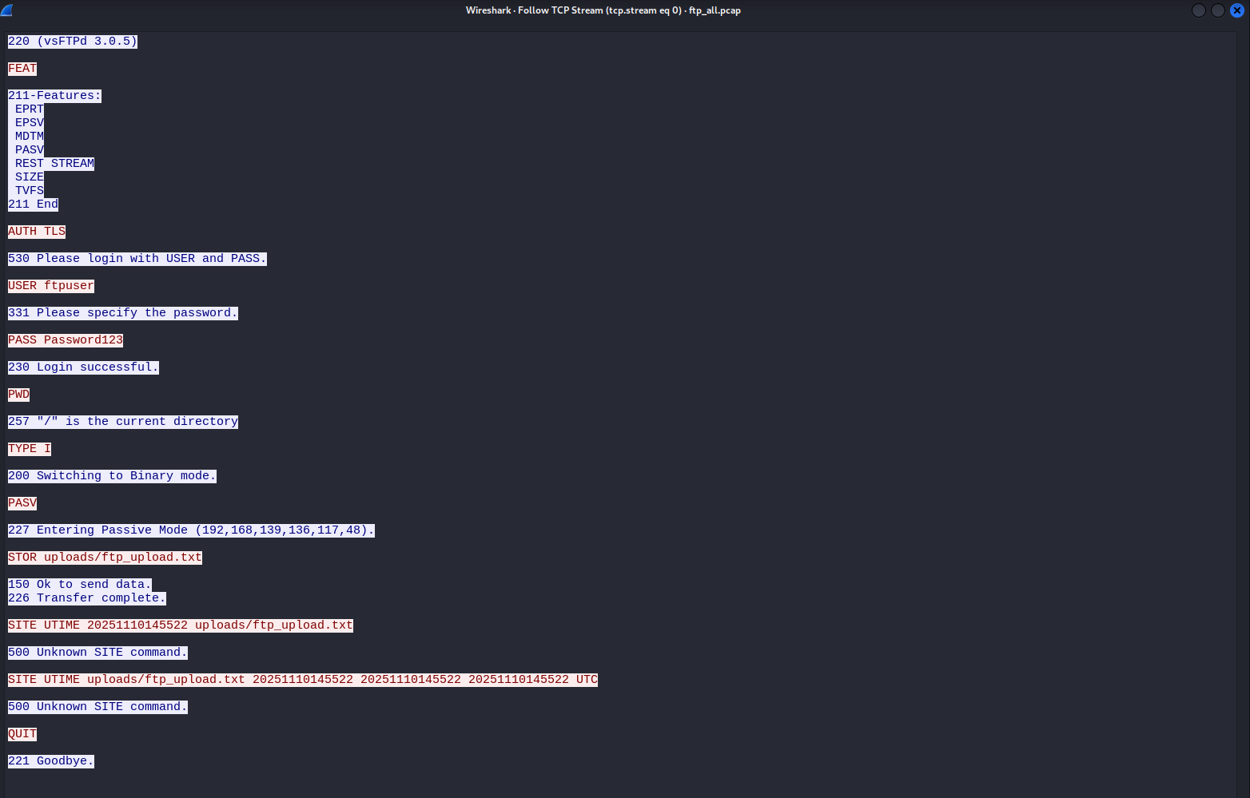
Open with wireshark GUI, we can also now all the information like tshark
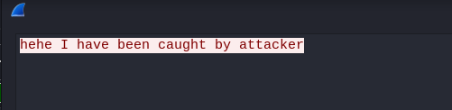
And for sure, this is what is inside the file ftp_upload.txt

- Active FTP capture:
+ Victim: 192.168.139.137
Upload using active mode
+ Attacker: ip address 192.168.139.135
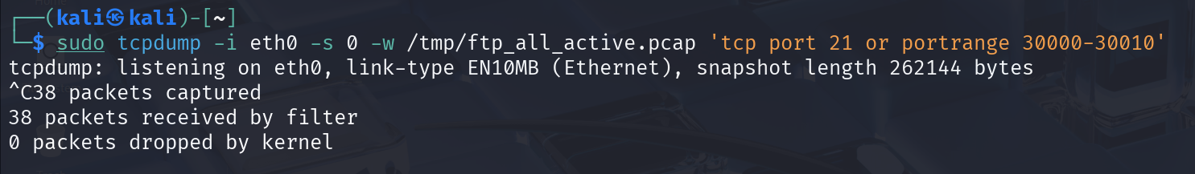
Attacker have successfully captured the packets.
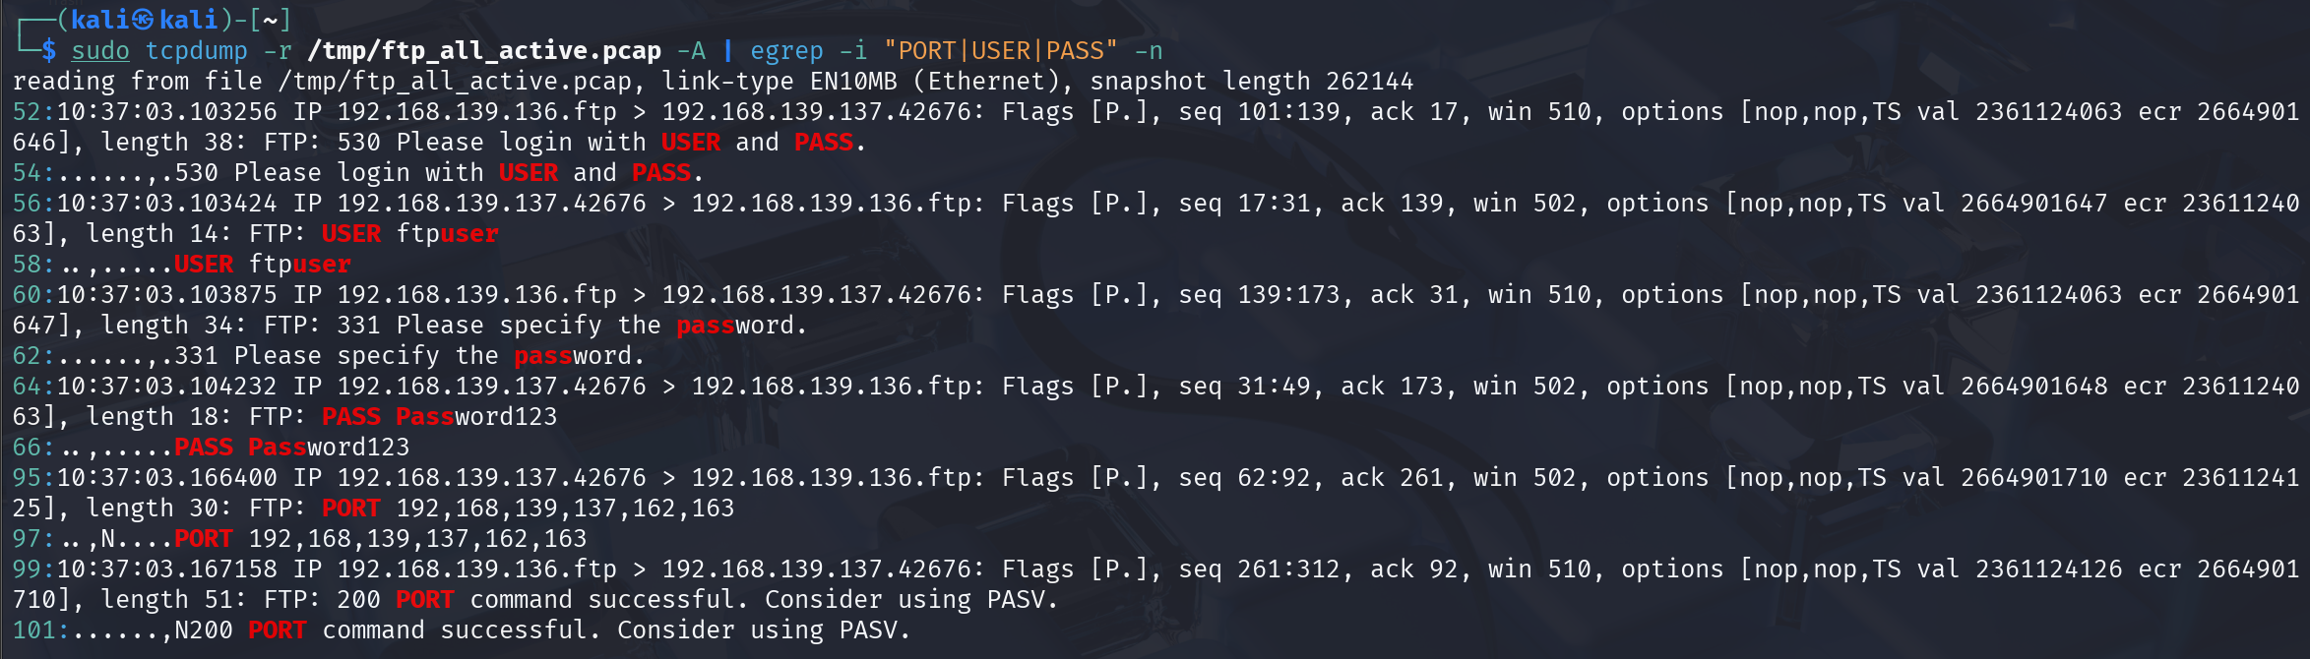
With this we can calculate the port with the formula: port= 162*256 + 163 = 41635.
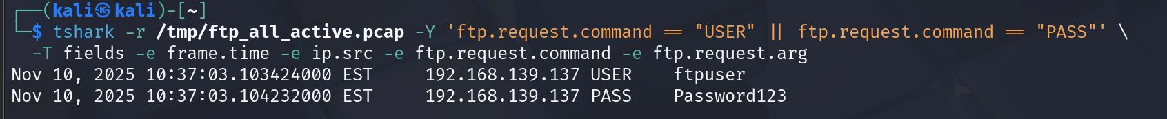
We can also see all the credentials here.
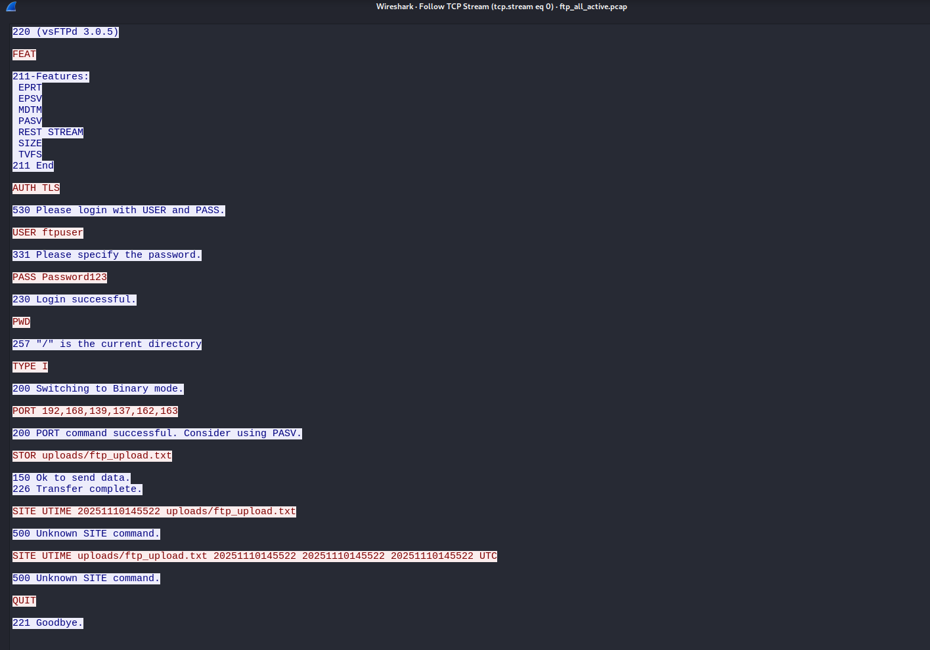
Open this file in wireshark, we can also see all the information.

Okay I have done this FTP lab, this is so fun and interesting for me to do this, really love these lab, now I have acquired more knowledge about FTP. (Hehe)

